Hebrews: The Supremacy of the Son of God pt. 51
Nov 9th || Outline: “God, the Regulator and Consumer of Worship”
Central Idea of the Text: The regulations of the worship in the OC were set by God to picture what Christ would do for us in the NC.
Specific Objective of the Text: To understand the intent of worship in the OC and look to Christ.

Text: Hebrews 9:1–10
Please just listen or follow along in your Bible.

Introduction: (v1,10)
- The foreignness of their situation for us.
  - Candlestick vs. Levi Stadium.
- Why go back to talking about the OC now?
  - It’s the history.
  - To know how God regulated worship in that time.
  - The regulations of worship in the OC were a copy of the reality in heaven.

The Earthly Tabernacle (vv2-5)
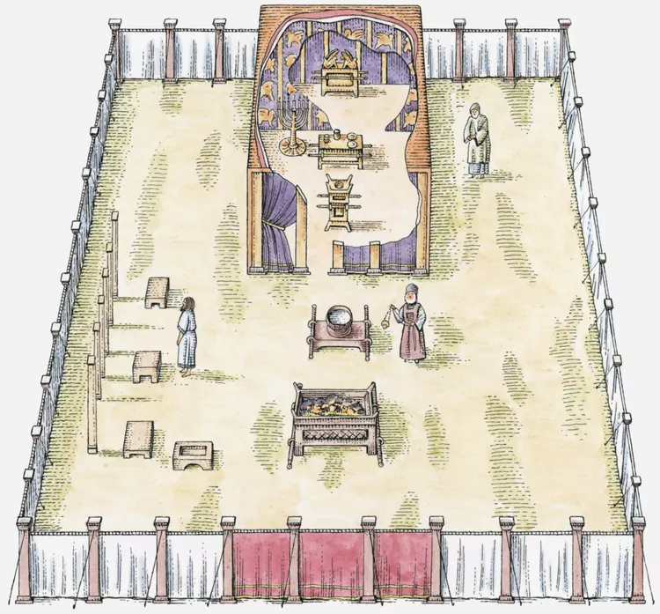
Hebrews: The Supremacy of the Son of God pt. 51
Nov 9th || Outline: “God, the Regulator and Consumer of Worship”
Central Idea of the Text: The regulations of the worship in the OC were set by God to picture what Christ would do for us in the NC.
Specific Objective of the Text: To understand the intent of worship in the OC and look to Christ.

Text: Hebrews 9:1–10
Please just listen or follow along in your Bible.

Introduction: (v1,10)
- The foreignness of their situation for us.
  - Candlestick vs. Levi Stadium.
- Why go back to talking about the OC now?
  - It’s the history.
  - To know how God regulated worship in that time.
  - The regulations of worship in the OC were a copy of the reality in heaven.

The Earthly Tabernacle (vv2-5)
- In the first part – lampstand, table of showbread – the Holy Place.
- The second part – Ark of the Covenant, altar of incense – the Most Holy place.
  - Incense altar functionally if not physically in there.
- Reasons as to why the Tabernacle and not the Temple is used.
  - No Ark in that 2nd temple.
  - No jar of mana, or Aaron’s Rod in the Ark in the 1st Temple.

The Earthly Service (vv.6-7)
- Lots of busy activity in the first section.
- Busy in the second section only once a year.
- All of this is to show that access to God was very limited.
  - Entering the Most Holy Place with the Ark carried with it danger – death.
  - Pompey and Crassus – but the Ark is gone by then.
  - Even the high priest, has to make special provision to meet with God.
- The regular and yearly activity reveal that this was pointing to a problem in the OC – access was limited and sin was not sufficiently taken care of.

The Spiritual Meaning (vv.8-10)
- With the ministry of the OC, full access to God was not open.
- Mans sin was a problem for man – and so God limited access to Himself.
- All the external acts in the Old Covenant couldn’t perfect the conscience.
  - Same is true in the New Covenant.
    - Not all who professes to be in the NC, are so.
- The time of reformation – the inbreaking of the New Covenant.

Application:
- We still have a guilt problem today.
- External worship acts don’t cleanse the conscience.
- Look to Christ who cleans the conscience.

- In the first part – lampstand, table of showbread – the Holy Place.
- The second part – Ark of the Covenant, altar of incense – the Most Holy place.
  - Incense altar functionally if not physically in there.
- Reasons as to why the Tabernacle and not the Temple is used.
  - No Ark in that 2nd temple.
  - No jar of mana, or Aaron’s Rod in the Ark in the 1st Temple.

The Earthly Service (vv.6-7)
- Lots of busy activity in the first section.
- Busy in the second section only once a year.
- All of this is to show that access to God was very limited.
  - Entering the Most Holy Place with the Ark carried with it danger – death.
  - Pompey and Crassus – but the Ark is gone by then.
  - Even the high priest, has to make special provision to meet with God.
- The regular and yearly activity reveal that this was pointing to a problem in the OC – access was limited and sin was not sufficiently taken care of.

The Spiritual Meaning (vv.8-10)
- With the ministry of the OC, full access to God was not open.
- Mans sin was a problem for man – and so God limited access to Himself.
- All the external acts in the Old Covenant couldn’t perfect the conscience.
  - Same is true in the New Covenant.
    - Not all who professes to be in the NC, are so.
- The time of reformation – the inbreaking of the New Covenant.

Application:
- We still have a guilt problem today.
- External worship acts don’t cleanse the conscience.
- Look to Christ who cleans the conscience.

